Day 1: Setting up a Windows Environment

I would like to thank the universe for giving me this opportunity to learn from a professional like Casey. I think somewhat we think alike when it comes to getting more performance out of the hardware.

This whole stream was dedicated to setting up the dev environment I will be working in for the next 2 years. Well, this stream was 4 years old so some things have changed. This affected my learning a little bit, I would say it benefited me. Because I have to look into things more deeply.

List of things, I learned in this stream:

Subst: This is a CMD command to create a virtual drive of the project folder. This is very useful since I don’t have to navigate through the whole directory to reach my project folder.

Changing the target string inside a cmd shortcut to run commands as soon as I open them

%windir%\system32\cmd.exe /k R:\Handmade\misc\shell.bat

That shell has commands to open the visual studio debugger x64 version.

@echo off
call "C:\Program Files (x86)\Microsoft Visual Studio\2019\Community\VC\Auxiliary\Build\vcvarsall.bat" x64
set path=R:\Handmade\misc;%path%

The shell file also sets this directory to the path

Then we have the build.bat

@echo off
mkdir ..\..\build
pushd ..\..\build
cl -Zi r:\Handmade\code\win32_handmade.cpp user32.lib
popd

Cl to compile stuff and -Zi to generate additional files that I don’t know what they do.
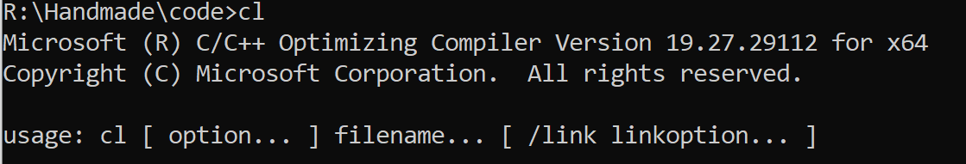

This was it, I think. Casey talked about how the CRT library is forcefully included in our source code to run some code but we don’t need it. He will teach us how to make our functions and libraries.

Devenv win32.exe to call the debugger

Martins has a post regarding the CRT library and how to remove it, I did not implement it yesterday but I'll do it today.

DAY 2: Setting up the win32 window

Any modern game has a renderer which ships the code to the graphics card to implement stuff. But the implementation is hidden from us. We will be trying to implement that ourselves from the processor itself.

To do that, we will need a window to render things on.

WIND Class is a structure for setting up a window in windows.
This structure has these elements that we need to set in order to know what kind of window we want.
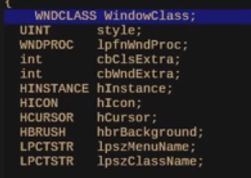
Since we don’t need to set every value in the WNDCLASS we will use an initializer to set in the values. Basically, we will type WindowClass = {}; that will set everything to zero automatically.

GetModuleHandle function to get the instance of the program you are running.

DC is device context which windows uses to keep the state of drawing while we are intefacing with it to draw to our window

CS.CLASSDC and CS.OWNDC are both flags to set device context(something that we will need to draw, that Casey will explain later) for windows.

OWNDC will allocate a dc for every window and CLASSDC also does this but not for every window.

Since we are creating only one window, both will work but we are using OWNDC to have over every window get a device context, in case we create another window.

An important thing to note about Casey is that he still wants to look if things are relevant and not want to teach irrelevant stuff just because it’s the way he always does things.

CS_HREDRAW AND CS_VREDRAW are flags used to tell windows whether to redraw stuff, whenever the window is resized.

WndProc is a pointer to a windows callback function for a window.

WindowCallback function has 4 parameters

HWMD -> Handle to the window
UNIT -> Messages, windows wants us to handle

